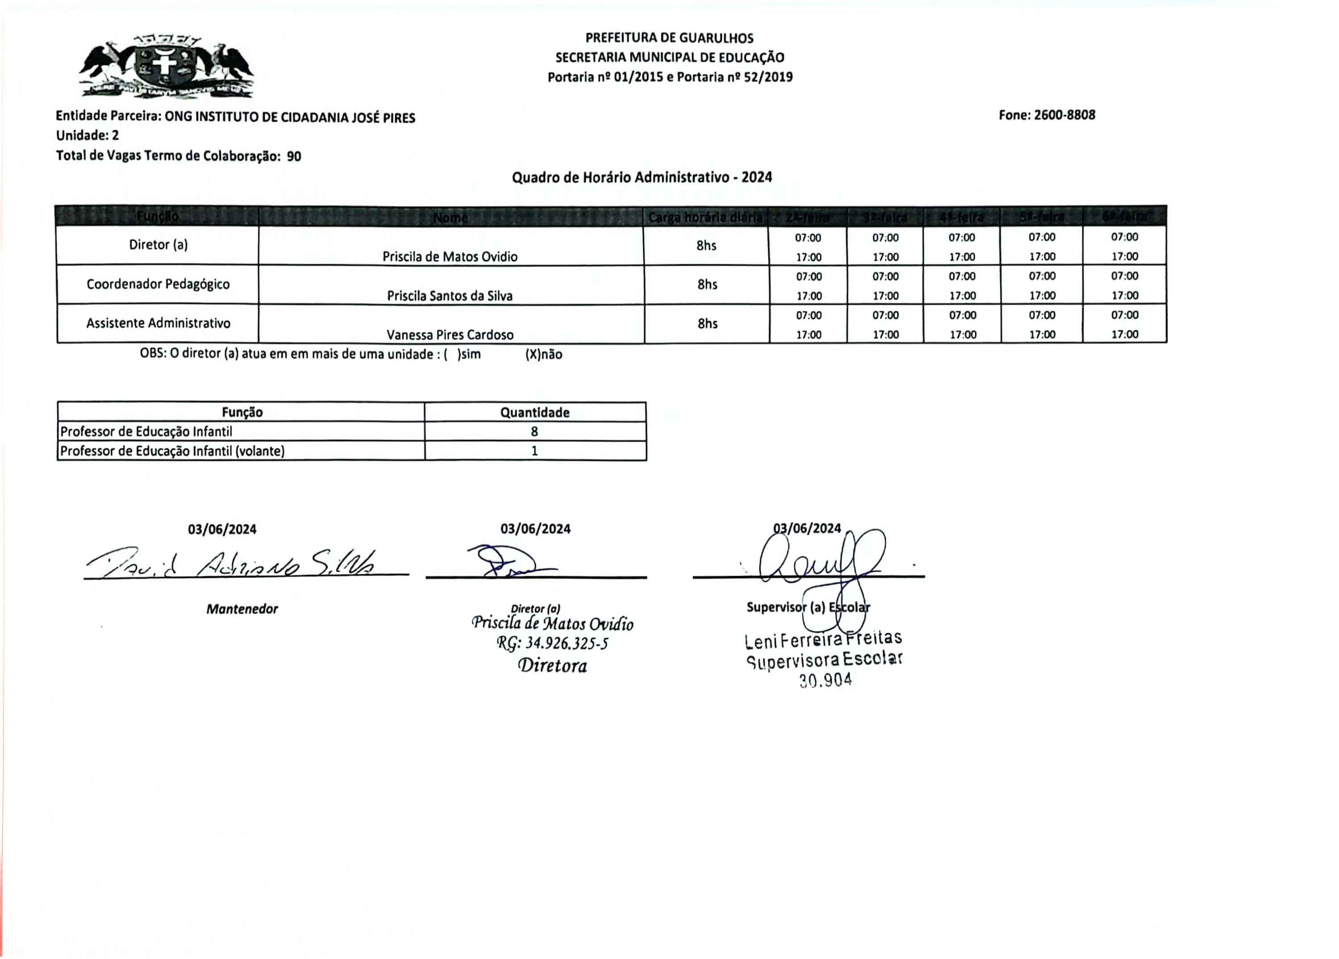


䑩杩瑡汩穡摯⁣潭⁃慭卣慮湥r

